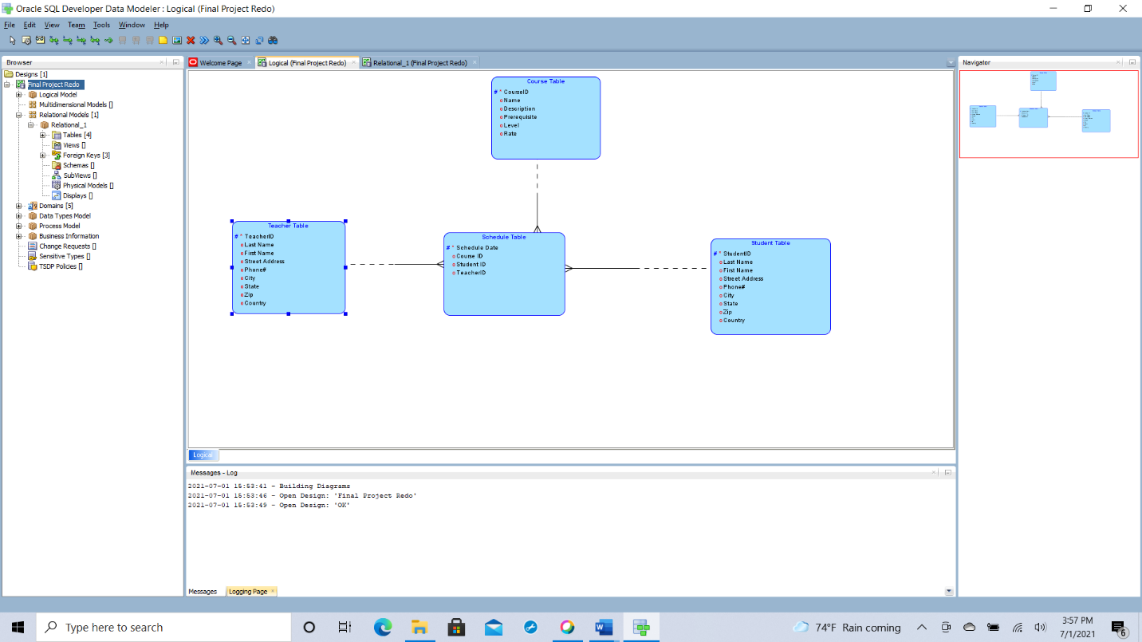

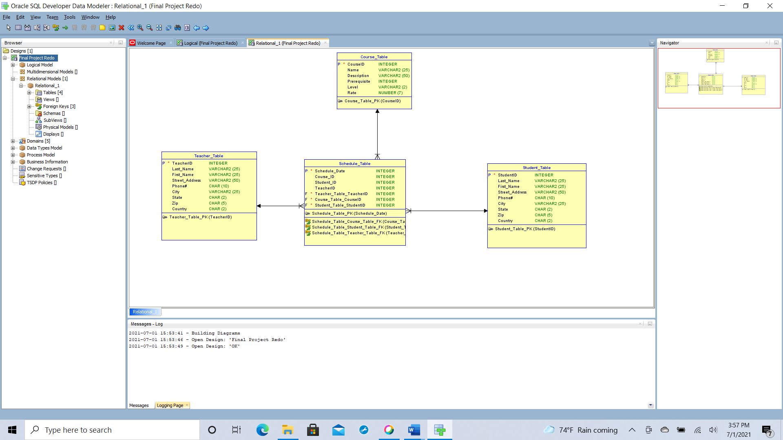

-- Generated by Oracle SQL Developer Data Modeler 19.2.0.182.1216

-- at: 2021-07-01 16:02:33 EDT

-- site: SQL Server 2012

-- type: SQL Server 2012

CREATE TABLE course_table (

courseid INTEGER NOT NULL,

name VARCHAR(25),

description VARCHAR(50),

prerequisite INTEGER,

level VARCHAR(2),

rate NUMERIC(7)

)

go

EXEC sp_addextendedproperty 'MS_Description' , '1,2,3' , 'USER' , 'dbo' , 'TABLE' , 'Course_Table' , 'COLUMN' , 'Level' go

ALTER TABLE Course_Table ADD constraint course_table_pk PRIMARY KEY CLUSTERED (CourseID)

WITH (

ALLOW_PAGE_LOCKS = ON ,

ALLOW_ROW_LOCKS = ON ) go

CREATE TABLE schedule_table (

schedule_date INTEGER NOT NULL,

course_id INTEGER,

student_id INTEGER,

teacherid INTEGER,

teacher_table_teacherid INTEGER NOT NULL,

course_table_courseid INTEGER NOT NULL,

student_table_studentid INTEGER NOT NULL

)

go

ALTER TABLE Schedule_Table ADD constraint schedule_table_pk PRIMARY KEY CLUSTERED (Schedule_Date)

WITH (

ALLOW_PAGE_LOCKS = ON ,

ALLOW_ROW_LOCKS = ON ) go

CREATE TABLE student_table (

studentid INTEGER NOT NULL,

last_name VARCHAR(25),

first_name VARCHAR(25),

street_address VARCHAR(50),

phone# CHAR(10),

city VARCHAR(25),

state CHAR(2),

zip CHAR(5),

country CHAR(2)

)

go

ALTER TABLE Student_Table ADD constraint student_table_pk PRIMARY KEY CLUSTERED (StudentID)

WITH (

ALLOW_PAGE_LOCKS = ON ,

ALLOW_ROW_LOCKS = ON ) go

CREATE TABLE teacher_table (

teacherid INTEGER NOT NULL,

last_name VARCHAR(25),

first_name VARCHAR(25),

street_address VARCHAR(50),

phone# CHAR(10),

city VARCHAR(25),

state CHAR(2),

zip CHAR(5),

country CHAR(2)

)

go

ALTER TABLE Teacher_Table ADD constraint teacher_table_pk PRIMARY KEY CLUSTERED (TeacherID)

WITH (

ALLOW_PAGE_LOCKS = ON ,

ALLOW_ROW_LOCKS = ON ) go

ALTER TABLE Schedule_Table

ADD CONSTRAINT schedule_table_course_table_fk FOREIGN KEY ( course_table_courseid )

REFERENCES course_table ( courseid )

ON DELETE NO ACTION

ON UPDATE no action go

ALTER TABLE Schedule_Table

ADD CONSTRAINT schedule_table_student_table_fk FOREIGN KEY ( student_table_studentid )

REFERENCES student_table ( studentid )

ON DELETE NO ACTION

ON UPDATE no action go

ALTER TABLE Schedule_Table

ADD CONSTRAINT schedule_table_teacher_table_fk FOREIGN KEY ( teacher_table_teacherid )

REFERENCES teacher_table ( teacherid )

ON DELETE NO ACTION

ON UPDATE no action go

-- Oracle SQL Developer Data Modeler Summary Report:

--

-- CREATE TABLE 4

-- CREATE INDEX 0

-- ALTER TABLE 7

-- CREATE VIEW 0

-- ALTER VIEW 0

-- CREATE PACKAGE 0

-- CREATE PACKAGE BODY 0

-- CREATE PROCEDURE 0

-- CREATE FUNCTION 0

-- CREATE TRIGGER 0

-- ALTER TRIGGER 0

-- CREATE DATABASE 0

-- CREATE DEFAULT 0

-- CREATE INDEX ON VIEW 0

-- CREATE ROLLBACK SEGMENT 0

-- CREATE ROLE 0

-- CREATE RULE 0

-- CREATE SCHEMA 0

-- CREATE SEQUENCE 0

-- CREATE PARTITION FUNCTION 0

-- CREATE PARTITION SCHEME 0

--

-- DROP DATABASE 0

--

-- ERRORS 0

-- WARNINGS 0